
<Understanding Organisational Participation and Success in IETF Standardisation>
<Haozhe Zhang>
School of Computing Science
Sir Alwyn Williams Building
University of Glasgow
G12 8RZ
A dissertation presented in part fulfillment of the requirements of the Degree of Master of Science at the University of Glasgow
<Date of submission placed here>

Abstract
<Abstract goes here…>

Education Use Consent
I hereby give my permission for this project to be shown to other University of Glasgow students and to be distributed in an electronic form.
<Please note that you are under no obligation to sign this declaration, but doing so would help future students.>

Name: Signature:

Acknowledgements
<Acknowledgements go here>

Contents
<Update the table of contents by right-clicking on it and selecting Update Field… and then select page numbers only.>

Chapter 1 Introduction <This is Heading 1> 1
1.1 Introduce the project. 1
1.2 Background. 1
1.1 Problem Statement. 1
Chapter 2 Background and Literature Review 2
2.1 Internet Standards and Standardisation . 1
2.2 Previous Studies on the IETF. 1
2.2.1 Social Structure of the IETF 1
2.2.2 Characteristics of Successful Standards 1
2.3 Research Gap. 1
Chapter 3 Research Aim, Objectives and Questions 3
3.1 Aim. 1
3.2 Research Question. 1
Chapter 4 Proposed Methodology 4
4.1 Research Disign. 1
4.2 Data Source. 1
4.3 Data Extration. 1
4.4 Data Cleaning. 1
Chapter 5 Expected Outputs and Contributions 4
Chapter 6 Risks and Mitigation 4
Appendix A <Name of appendix> 1
Appendix B <Another appendix> 2
Bibliography 3

Introduction

1.1 Introduce the project.
The Internet has become essential infrastructure supporting modern communication, commerce, healthcare, transportation and public services. The interoperability of these systems depends heavily on open technical standards that enable heterogeneous devices, networks and software developed by different organisations to communicate effectively. Among the organisations responsible for developing such standards, the Internet Engineering Task Force (IETF) has played a particularly influential role through the development of protocols including TCP/IP, HTTP, TLS, IPv6 and QUIC.
Unlike many formal standards organisations, the IETF operates through an open and consensus-driven process in which participation is open to individuals from academia, industry and research institutions. Proposed standards are initially submitted as Internet-Drafts, which undergo multiple rounds of technical discussion, revision and community review before some are eventually published as Request for Comments (RFCs). However, only a relatively small proportion of Internet-Drafts ultimately become RFCs, while many expire or are abandoned during the standardisation process.
Understanding why some Internet-Drafts successfully progress to RFC publication is important for both researchers and practitioners. Recent availability of comprehensive metadata from the IETF Datatracker database provides an opportunity to investigate this process quantitatively. Nevertheless, existing studies have largely focused on the social structure of the IETF community or the deployment of published standards, while comparatively little attention has been paid to identifying the factors associated with publication success using large-scale Datatracker metadata.
This study therefore analyses metadata extracted from the official IETF Datatracker database to investigate how document characteristics, revision history, organisational participation and working-group involvement influence Internet-Draft publication outcomes. In addition, machine-learning techniques will be explored to evaluate whether publication success can be predicted from document metadata.
1.2 Background
The Internet Engineering Task Force (IETF) is an open international standards development organisation responsible for developing Internet protocols. Unlike formal standards organisations, the IETF operates through an open, consensus-driven process where participation is open to anyone. Its outputs are published as Request for Comments (RFCs), many of which define protocols used across the Internet.
The Internet has become critical infrastructure for modern society. The interoperability of Internet technologies relies on open standards. The Internet Engineering Task Force (IETF) is one of the world's most influential standards development organisations and is responsible for many widely deployed Internet protocols, including TCP, IPv6, QUIC, HTTP/3 and TLS.
Thousands of Internet-Drafts have been submitted since the IETF was established. However, only a proportion eventually become RFCs. Understanding what factors influence this process is valuable because it improves understanding of Internet standardisation and may help explain how successful technical standards emerge.

1.3 Problem Statement
Despite the importance of IETF standards, little empirical evidence exists regarding why some Internet-Drafts eventually become RFCs while many others fail during the standardisation process.

Chapeter 2 Background and Literature Review
2.1 Internet Standards and Standardisation
Internet interoperability depends on open standards that enable devices and software developed by different organisations to communicate. The Internet Engineering Task Force (IETF) is one of the most influential standards development organisations and has produced protocols such as TCP/IP, HTTP, TLS and QUIC. Standards are developed through an open and consensus-driven process in which Internet-Drafts are reviewed, revised and, if successful, published as RFCs

2.2 Previous Studies on the IETF
Previous studies related to the IETF can be broadly grouped into three themes. The first examines the structure and participation of the IETF community. The second focuses on Internet standardisation and the characteristics of successful standards. The third explores the use of IETF Datatracker metadata for empirical analysis. Reviewing these themes helps identify the current limitations in the literature and motivates the research questions addressed in this project.
2.2.1 Studies on the IETF Community.
Previous research has examined how the IETF community is organised and how collaboration influences standards development. Studies have shown that the IETF exhibits a core–periphery structure in which a relatively small number of highly active participants contribute disproportionately to discussions and document development. Other studies have investigated patterns of collaboration among authors and the role of Working Groups in facilitating consensus.
These studies provide valuable insights into the social organisation of the IETF and demonstrate that participation patterns influence the standards development process. However, most focus on the behaviour of participants rather than the publication outcomes of Internet-Drafts. They rarely investigate whether organisational participation or Working Group characteristics are associated with RFC publication success.
Therefore, existing research provides useful background for RQ2, but does not directly explain how organisational participation and Working Group characteristics influence Internet-Draft publication outcomes.
2.2.2 Studies on Document Evolution in Internet Standardisation
Previous studies have examined how IETF documents evolve during the standardisation process. Internet-Drafts typically undergo multiple revisions, technical review and community discussion before some are eventually published as RFCs. Revision count and development duration therefore provide observable indicators of document activity and progression through the standardisation process.
McQuistin et al. found that RFCs are taking longer to produce and are preceded by a growing number of draft revisions. Their analysis suggests that the IETF standardisation process has become increasingly complex over time. However, the study focused primarily on RFCs that had already been published and did not systematically compare successful and unsuccessful Internet-Drafts.
This leaves an important question unanswered: whether revision history and other document-development characteristics are associated with the probability that an Internet-Draft will eventually become an RFC. This question is addressed by RQ1.
2.2.3 Studies Using Datatracker Metadata
More recent studies have begun to utilise IETF Datatracker metadata to investigate aspects of document management and standards development. The availability of structured metadata provides opportunities for large-scale quantitative analysis that were previously difficult to conduct.
However, current studies generally employ descriptive statistics and exploratory analyses. Comparatively little work has investigated predictive modelling using Datatracker metadata, and the feasibility of predicting RFC publication success using machine-learning techniques remains largely unexplored.
This limitation directly motivates RQ3, which investigates whether machine-learning models can accurately predict Internet-Draft publication outcomes using document metadata.

2.3 Research Gap
The literature review highlights three important gaps.
First, previous studies have focused primarily on participation patterns within the IETF community rather than analysing how organisational participation and Working Group characteristics influence publication success.
Second, while Internet standardisation has been widely studied, comparatively little research has examined which document characteristics and development history are associated with successful Internet-Draft publication.
Third, although Datatracker metadata has enabled new empirical studies, few researchers have explored predictive modelling of publication outcomes using machine-learning techniques.
Accordingly, this project addresses these three gaps through the research questions presented in Chapter 3.

Chapter 3 Research Aim, Objectives and Questions
3.1 Aim
To investigate the factors that influence the success of Internet-Drafts using the IETF Datatracker database.
3.2 Research Questions
RQ1：Which Document characteristics, revision history and publication outcomes are associated with successful publication of Internet-Drafts as RFCs?
Previous studies have mainly examined published RFCs rather than the characteristics of Internet-Drafts before publication. This question therefore investigates whether document characteristics and development history are associated with publication success.
RQ2：How do organisational participation and Working Group characteristics influence the likelihood of Internet-Draft publication?
Previous studies have shown that participation and collaboration are important within the IETF community, but relatively little attention has been paid to how organisational affiliation and Working Group characteristics relate to publication outcomes. This question therefore examines whether differences between organisations and Working Groups are associated with RFC publication success

RQ3 Can machine-learning models accurately predict whether an Internet-Draft will eventually become an RFC using document metadata?
Building upon the findings of RQ1 and RQ2, this question evaluates whether document metadata can be used to develop predictive models of publication success. The results will provide insight into the predictive value of different document characteristics and assess the feasibility of machine-learning approaches in this context.

Chapter 4 Proposed Methodology
4.1 Research Design
This project adopts a quantitative, data-driven research design based on secondary data obtained from the IETF Datatracker database. A quantitative approach is appropriate because the research aims to identify statistical relationships between document characteristics, organisational participation and publication outcomes across a large number of Internet-Drafts. Rather than testing a single predefined hypothesis, the study explores multiple factors associated with successful RFC publication and evaluates whether publication outcomes can be predicted using machine-learning techniques. This design directly supports the three research questions by enabling descriptive, statistical and predictive analyses of structured metadata.
4.2 Sample and Dataset
The study uses an offline SQLite snapshot of the official IETF Datatracker database provided by the project supervisor. The dataset contains metadata describing Internet-Drafts, published RFCs, document revisions, working groups, authors, organisational affiliations and document history. The unit of analysis is the Internet-Draft. Drafts that have sufficient metadata for analysis will be included, while incomplete or duplicate records will be removed during the data-cleaning stage.
4.3 Data Collection
The study uses an offline SQLite snapshot of the official IETF Datatracker database provided by the project supervisor. The dataset contains metadata describing Internet-Drafts, published RFCs, document revisions, working groups, authors, organisational affiliations and document history. The unit of analysis is the Internet-Draft. Drafts that have sufficient metadata for analysis will be included, while incomplete or duplicate records will be removed during the data-cleaning stage.
4.4 Data Cleaning
The study uses an offline SQLite snapshot of the official IETF Datatracker database provided by the project supervisor. The dataset contains metadata describing Internet-Drafts, published RFCs, document revisions, working groups, authors, organisational affiliations and document history. The unit of analysis is the Internet-Draft. Drafts that have sufficient metadata for analysis will be included, while incomplete or duplicate records will be removed during the data-cleaning stage.
4.5 Variables

Variable | Type | Description | Realted RQ
RFC publication success | Dependent | Whether an Internet-Draft became an RFC | RQ1–RQ3
Revision count | Numerical | Number of document revisions | RQ1
Draft age | Numerical | Number of unique authors | RQ1
Author count | Numerical | Number of unique authors | RQ1
Organisation | Categorical | Normalised author affiliation | RQ2
Working Group | Categorical | Responsible IETF Working Group | RQ2
Area | Categorical | IETF Area | RQ2

4.6 Data Analysis
Stage 1: Descriptive Analysis
Descriptive statistics will summarise the characteristics of Internet-Drafts, including publication success rates, revision counts, document age and author participation.

Stage 2: Comparative and Statistical Analysis
Comparative analyses will examine differences between successful and unsuccessful Internet-Drafts. Statistical methods, including correlation analysis and appropriate significance tests, will be used to investigate relationships between document characteristics, organisational participation and publication outcomes.

Stage 3: Predictive Modelling
Machine-learning algorithms such as Logistic Regression, Random Forest and XGBoost (subject to feasibility) will be evaluated to predict RFC publication success. Model performance will be assessed using accuracy, precision.
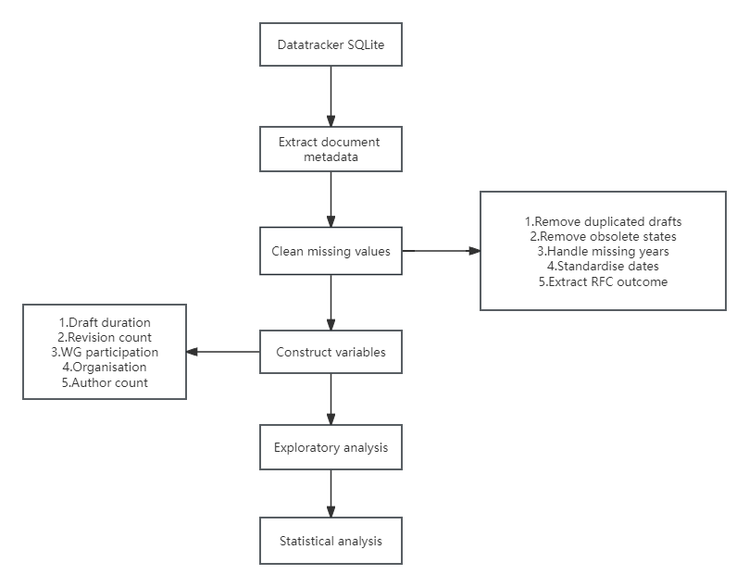

Chapter 5 Risks and Mitigation
Challenge 1 Missing metadata.
Mitigation
Missing values will be analysed systematically. Records with insufficient metadata for key variables will be excluded where appropriate, while non-critical missing values will be handled using suitable data-cleaning techniques.
Challenge 2 Data Integration Across Multiple Tables
Mitigation
SQL joins and unique identifiers will be used to integrate related tables. Intermediate datasets will be validated before analysis.
Challenge 3 Imbalanced Publication Outcomes
Description
Only a proportion of Internet-Drafts are eventually published as RFCs, which may affect predictive model performance.
Mitigation
Appropriate evaluation metrics (e.g., precision, recall and F1-score) and resampling techniques will be considered where necessary.

Challenge 4 Defining Publication Success
Description
Internet-Drafts may remain active, expire or be replaced without becoming RFCs. Defining publication success consistently is therefore essential for reliable analysis.
Mitigation
Publication success will be defined using explicit criteria based on RFC publication records and document status. Drafts that remain active at the time of data collection will be considered separately where appropriate.

Chanllenge 5 6 7 8 9..........
No others have been encountered yet, to be continued.

Chapter 6 Expected Outputs and Contributions
Academic Contribution
This study contributes to the literature by providing one of the first comprehensive quantitative analyses of Internet-Draft publication success using the complete IETF Datatracker database.
Practical Contribution
The findings may help Working Groups, standards developers and participating organisations better understand the characteristics associated with successful standardisation, thereby supporting more effective management of the standards development process.
Expected Outputs
The project is expected to produce a cleaned and integrated analytical dataset derived from the IETF Datatracker database, together with reproducible Python and SQL scripts for data extraction and processing. The analysis will generate descriptive statistics on Internet-Draft publication outcomes, comparative results across document characteristics, organisations and Working Groups, and visualisations showing publication trends, revision behaviour and differences in success rates. If predictive modelling is feasible, the project will also report model performance using metrics such as precision, recall, F1-score and ROC-AUC, together with feature-importance results.
1.cleaned analytical dataset
2.SQL and Python scripts
3.overall RFC publication success rate
4.success rates by organisation and Working Group
5.distributions of revision count and draft age
6.time-series visualisations
7.statistical test results
8.model evaluation results
9.feature-importance plot
Chapter 7 Work Plan

Week | Task
5-6 | Develop SQL queries and Python scripts for data extraction. Clean and integrate data from multiple Datatracker tables, handle missing values and standardise organisational affiliations.
7-8 | Perform exploratory data analysis and descriptive statistics. Analyse document characteristics, revision history, organisational participation and Working Group activity, and generate visualisations to address RQ1 and RQ2.
9-10 | Conduct statistical analyses and, where appropriate, develop and evaluate machine-learning models to address RQ3. Interpret the findings and compare them with previous studies.
10-12 | prepare for submission.

